Sinclair Inlet Chapter No. 80 National Sojourners, Inc

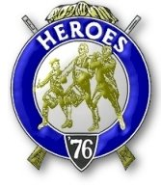

Bremerton, Washington
Our website address is: www.telebyte.com/masons/sojourn/index.htm

March 2013 Newsletter

Chapter Officers 2012-2013
President | HMCM Joseph MacIntyre | 360-275-0589 | haggis@wavecable.com
1st Vice President | Mr. Peter Dawson | 360-779-8219 | etypebubba@aol.com
2nd Vice President | CPO Stephen Quance | 360-731-5552 | sdquance@yahoo.com
Secretary/Treasurer | Mr. Charles Yankosky | 206-780-0563 | cyankosky@yahoo.com
Marshal | None
Chaplain | Mr. Richard Dexter | 360-692-6876 | rdexter@tscnet.com
Color Bearer | None

Hero Camp Officers 2012-2013
Commander | Col William Biscomb | 206-842-6417 | milfordbiscomb@comcast.net
Chief of Staff | Mr. Peter Dawson | 360-779-8219 | etypebubba@aol.com
Adjutant | MMCM Henry Carman | 360-698-4776 | hankcarman@wavecable.com

Meeting Notice!
We will meet at VFW Post #239, 190 Dora Ave, Bremerton on Friday, 8 Mar. Social hour and dinner begins at 1800, meeting at 1900 hours. Ladies and guests are always welcome at the meeting and are urged to attend.
The associated Lewis and Clark Camp of the Hero's of '76 meets immediately following the Sojourner meeting and is open to all Hero's.
Don’t forget to wear your Medals!
Highlights of the 7 Feb Meeting
Vice Pres. Peter Dawson opened the meeting with Dick Dexter as Chaplain and Wendell Dutt read the purposes of National Sojourners. It was announced that the National Secretary/Treasurer Maj. Nelson Newcombe will not be running for re-election this year. Therefore a replacement will be needed by mid 2013. Area Rep Wendell Dutt reported that we need to pay $16 to NW Rep. Marion Windell to get an add run in this year’s National Convention booklet. This year Chapter 80 is putting on the joint installation in June. Des Moines is a central location so it considered the best place to meet. Dick Dexter is going on a trip to Ireland and Scotland and will not get home until May 31, so he probably won’t be there. The other members deferred to Joe MacIntyre, as President, to make the arrangements for the installation.
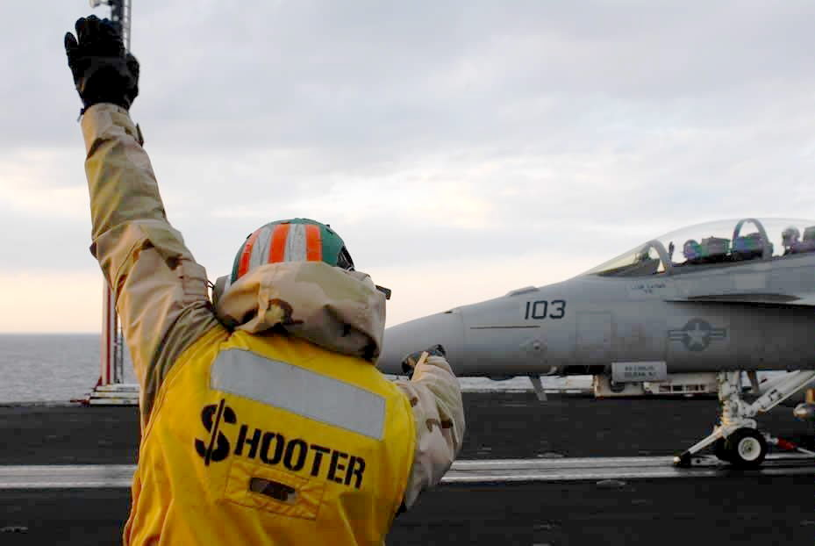
Col. Bill Biscomb was talking with the Cub Scouts, who meet at the Bainbridge lodge, about having our Heroes do a flag presentation. We would be prepared to do this just about any time. We just need to be given a date. The scouts thought it was OK, but one of their scout leaders has to get back to us.
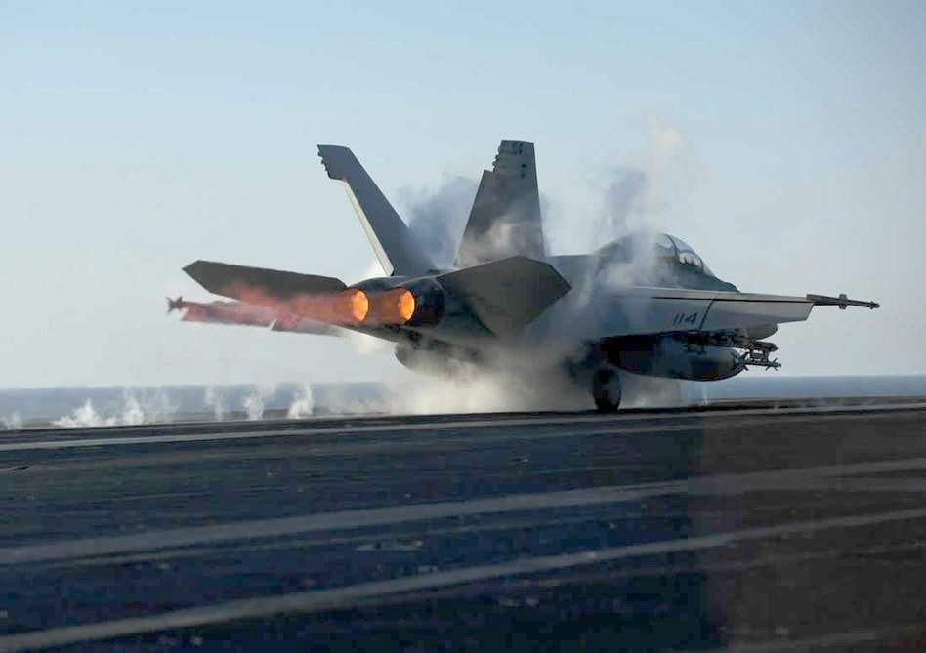
We also wanted to approach VFW Post 239 about doing a presentation. The other veterans’ organization, the Fleet Reserve, does a ceremony out at the ceme-tery on Memorial Day. Dick Dexter did “Old Glory” for them one year in a suit and a couple of years in Continental uniform. Then the next year they said
they said they didn’t need him, so he didn’t go back. But the were some people who thought that the “Old Glory” speech was really neat. The members delega-ted Pres. Joe to approach VFW #239 about doing a presentation.

Without Pres. Joe we didn’t get our night’s presentation. So a call was put out for jokes. Bill Bis-comb told a story about a young man who broke his arm skiing. There were complications and his right hand was amputated. He was right-handed so he couldn’t shave, comb his hair or write. So he wanted to kill himself by jumping off a 7 story building. He looked down off the building and saw a man with no arms jumping and dancing around. Reflecting for a moment he thought, here was a man with no arms dancing around as happy as a lark. And himself, still with one good arm, was wanting to kill himself. He went down to the street, where the man with no arms was still dancing around, to thanking him for saving his life. The man with no arms said he was only jump-ing around because he needed to scratch his bottom.
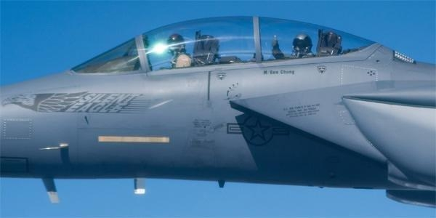

Sickness & Health. Hank Carman had been having trouble with his back and was just out of the hospital after back surgery. It was nice to see him moving around again.
F-18 Strike Eagle

